**Assignment 2**

**SQL Queries:**

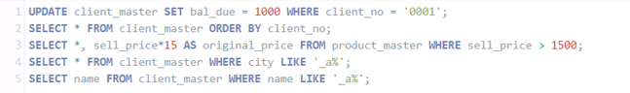



**Output:**





